
SCHOOL OF COMPUTING AND ENGINEERING SCIENCES (SCES)
BACHELOR OF SCIENCE IN ELECTRICAL AND ELECTRONICS
ENGINEERING (BSEEE)
DIGITAL CONTROL 1
Lab 3:
Inverted Pendulum
BY
Edward Mwongela – 142092

Group members
Harry Boto
Arnold Injeni
Samuel Mwichigi
Trevor Ayimba

Lecturer: Prof. Jackson Mbuthia
30th March 2025

Contents
Objective: 4
Learning Outcome: 4
Introduction 5
Components Required 5
Inverted Pendulum Assembly 5
Experiment Design – Write Code to Drive the Inverted Pendulum System 7
Robot car - BLDC Motor 7
Inverted Pendulum Dynamics 8
System Dynamics Equations in State Space 8
Inverted Pendulum Simulations 9
4.3.1 Assuming the pendulum angle θ to be the output and the linearized state space equations given in 4.2, determine a suitable sampling time with the loop closed with unity feedback. 10 Marks 9
4.3.2 With the loop closed with unity feedback and using the sampling time determined in 4.3.1, write python code to simulate and plot the pendulum output position θ(t) vs time and cart position x(t) vs time. 10 Marks 11
4.3.3 Determine the state feedback parameters of a suitable digital linear quadratic regulator (dlqr) to stabilize your inverted pendulum and the pre-compensator that will achieve the design specifications 10 Marks 14
4.3.4 Write python code to simulate and plot the pendulum output position θ(t) vs time and cart position x(t) vs time for the stabilized pendulum. 16
Discussions 20
6.2.1 How do the theoretical simulations compare with practical results? 20
6.2.2 How does closing the loop and adding the state feedback lqr controller change the response of the inverted pendulum? 20

List of figures
Figure 1. Brushless DC Motor – 3 Phase Star Connected Armature (Stator or Rotor) 5
Figure 2. Electronic Speed Controller 6
Figure 3. Motor, Microcontroller, ESC and Battery Mounting 6
Figure 4. Battery Clamp and Inverted Pendulum 6
Figure 5. Right Pendulum Bearing Holder and Left Pendulum Bearing Holder 7
Figure 6. Rotary Potentiometer and Speed Measurement Kit 7

Objective:
- Build an inverted pendulum [1]
- Implement control laws to smoothly drive an inverted pendulum

Learning Outcome:
- Apply code that drives an inverted pendulum
- Develop control algorithms to smoothly drive the inverted pendulum

Introduction

Components Required
• Microcontroller
• Four BLDC motors with two drivers (e.g., ESCs)
• Power supply (LiPo or Lithium-Ion battery)
• Computer for code development
• Robot car assembled in Lab_one

Inverted Pendulum Assembly
The inverted pendulum structure shown in Fig. 4.3 is mounted on a separate chassis plate secured above the battery of the robot car assembled in Lab_one. The inverted pendulum assembly uses two brushless motors shown on Fig. 4.1 to drive two front wheels of a robot car assembly. Two Electronic Speed Controllers (ESC) shown in Fig. 4.2 drive the front wheels. The back wheels are assembled to allow free movement. The inverted pendulum shown in Fig. 4.5 swings on two bearings secured on the right and left bearing holders shown in Fig. 4.6 and Fig. 4.7. The two bearing holders are secured on the separate chassis plate mounted above the battery of the robot car. Mount a rotary potentiometer shown in Fig. 4.8 on one of the bearing holders such that when the pendulum swings, you can measure the pendulum vertical angle θ by sampling the voltage output from the potentiometer. Mount a slotted wheel encoder shown in Fig. 4.9 on the robot car wheel shaft such that you can measure the robot car speed v(t). Each group will 3D print the parts shown in Fig.4.4, Fig.4.5, Fig. 4.6 and Fig. 4.7. The printing files for these parts are available on the drive. For more details on the inverted pendulum commercial setups, system modelling, dynamic equations, and simulations, refer to this reference “digitalcon trolapplicationsillustratedwithmatlab.pdf” available on the drive.
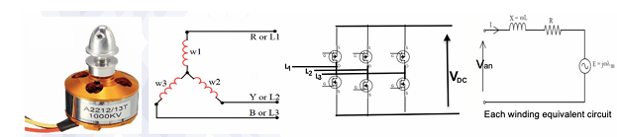
Figure 1. Brushless DC Motor – 3 Phase Star Connected Armature (Stator or Rotor)
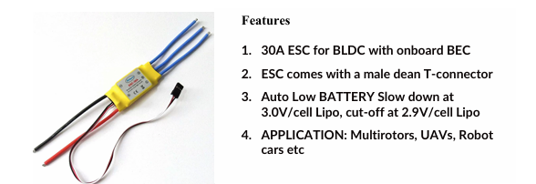
Figure 2. Electronic Speed Controller
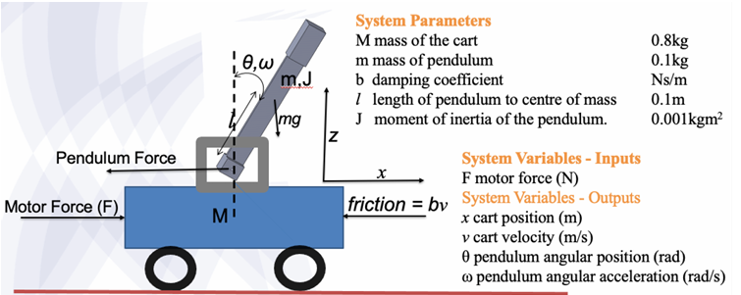
Figure 3. Motor, Microcontroller, ESC and Battery Mounting
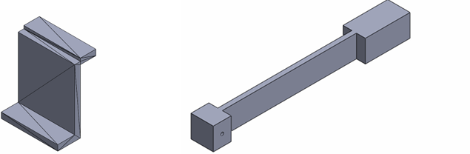
Figure 4. Battery Clamp and Inverted Pendulum
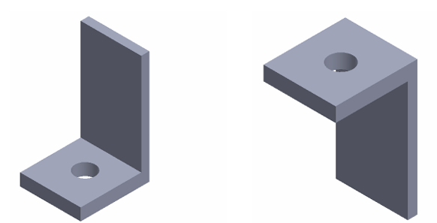
Figure 5. Right Pendulum Bearing Holder and Left Pendulum Bearing Holder
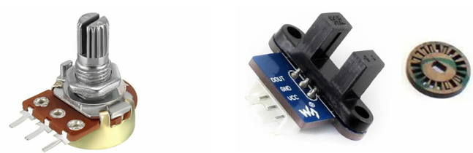
Figure 6. Rotary Potentiometer and Speed Measurement Kit

Experiment Design – Write Code to Drive the Inverted Pendulum System

Robot car - BLDC Motor
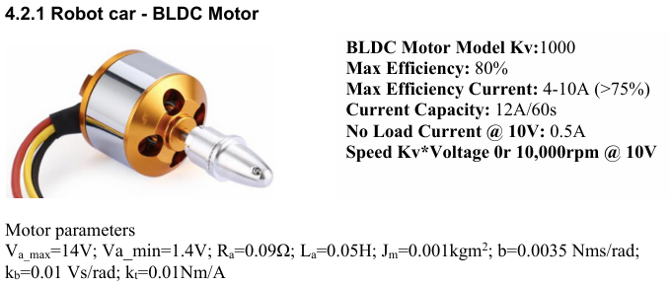

Inverted Pendulum Dynamics

System Dynamics Equations in State Space
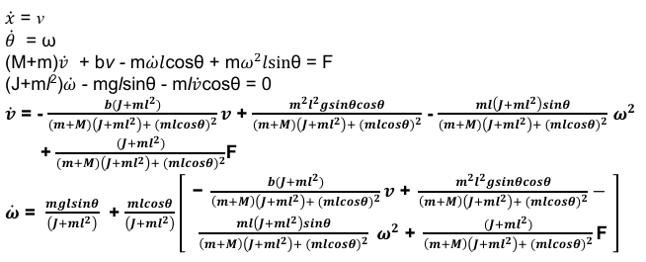
The pendulum shown in Fig. 4.3 is constrained to move in the vertical plane. For this system, the control input is the force that moves the cart horizontally and the outputs are the angular position θ of the pendulum and the horizontal position of the cart x. The system is unstable without control since the pendulum will simply fall over if the cart is not moved to balance it. [2]
Additionally, the dynamics of the system are nonlinear. The control objective is to balance the inverted pendulum by applying a force to the cart that the pendulum is attached to. A real-world example that relates directly to this inverted pendulum system is the altitude control of a booster rocket during takeoff.[3]

Design requirements
Settling time for x and θ of less than 5 seconds
Rise time for x of less than 0.5 seconds
Pendulum angle θ never more than 20 degrees (0.35 radians) from the vertical
Steady-state error of less than 2% for x and θ
A linearized approximation of the pendulum dynamics is obtained by assuming that for slight changes in angle θ, which is what is desirable cosθ =1, sinθ = θ, w^2 = 0
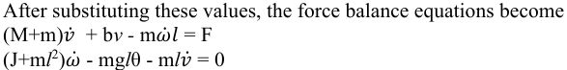
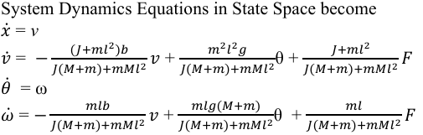
Where F is the input force in Newtons.
These are the equations to be solved using the Bridging Gap Algorithms for Discrete Data Control
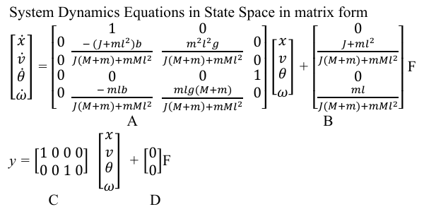

Inverted Pendulum Simulations

4.3.1 Assuming the pendulum angle θ to be the output and the linearized state space equations given in 4.2, determine a suitable sampling time with the loop closed with unity feedback. 10 Marks
To determine a suitable sampling time for the inverted pendulum system with the loop closed under unity feedback:
1. Understand the System Dynamics
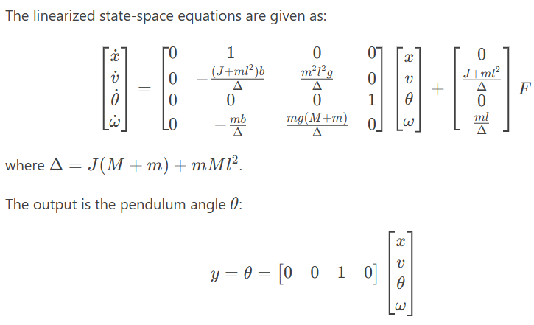
2. Determine the Open-Loop Poles
The poles of the open-loop system are the eigenvalues of the state matrix A. For an inverted pendulum, one of these poles will be in the right-half plane (unstable).
3. Close the Loop with Unity Feedback
Assume a proportional controller K is used to close the loop. The closed-loop system dynamics will depend on the choice of K.
4. Sampling Time Selection
A suitable sampling time T_s should be small enough to capture the fastest dynamics of the system. Commonly:
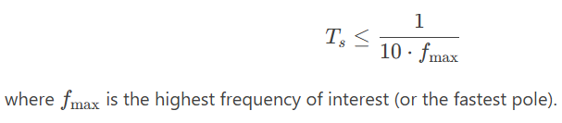
For the inverted pendulum:
- The fastest pole is typically associated with the pendulum's natural frequency ω_n = 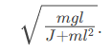
Calculate ω_n since
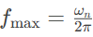
Given the system parameters:
- m=0.1 kg
- M=0.8 kg
- l=0.1m
- J=0.001kgm^2
- g=9.81m/s^2
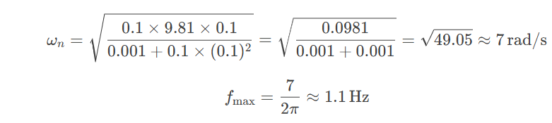
Thus, the sampling time should satisfy:
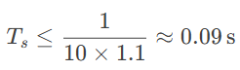
Thus:
T_s = 0.01s (10 ms).

4.3.2 With the loop closed with unity feedback and using the sampling time determined in 4.3.1, write python code to simulate and plot the pendulum output position θ(t) vs time and cart position x(t) vs time. 10 Marks
import numpy as np
import matplotlib.pyplot as plt
from scipy.signal import cont2discrete

# System parameters
M = 0.5 # mass of the cart (kg)
m = 0.2 # mass of the pendulum (kg)
l = 0.3 # length to pendulum center of mass (m)
g = 9.81 # gravity (m/s^2)
b = 0.1 # friction coefficient (Ns/m)
J = (1/3) * m * l**2 # moment of inertia of pendulum

# Common denominator
den = (J + m * l**2) * (M + m) - (m * l)**2

# Continuous-time state-space matrices
A = np.array([
[0, 1, 0, 0],
[0, -(J + m * l**2) * b / den, (m**2 * g * l**2) / den, 0],
[0, 0, 0, 1],
[0, -(m * l * b) / den, m * g * l * (M + m) / den, 0]
])
B = np.array([
[0],
[(J + m * l**2) / den],
[0],
[m * l / den]
])
C = np.array([[0, 0, 1, 0]]) # Output: θ
D = np.array([[0]])

# Sampling time
Ts = 0.01

# Discretize system
sys_d = cont2discrete((A, B, C, D), Ts)
Ad, Bd, _, _, _ = sys_d

# Simulation setup
T = np.arange(0, 5, Ts)
x = np.zeros((4, len(T)))
theta_out = []
x_out = []

# Simple proportional controller on θ
K_theta = 20

for k in range(1, len(T)):
theta = x[2, k-1]
u = -K_theta * theta # unity feedback
x[:, k] = Ad @ x[:, k-1] + Bd.flatten() * u
theta_out.append(x[2, k])
x_out.append(x[0, k])

# Plotting
plt.figure(figsize=(10, 5))

plt.subplot(2, 1, 1)
plt.plot(T[:-1], theta_out, label='Pendulum Angle θ(t)')
plt.axhline(0.35, color='r', linestyle='--', label='±20° limit')
plt.axhline(-0.35, color='r', linestyle='--')
plt.ylabel("θ (rad)")
plt.grid(True)
plt.legend()

plt.subplot(2, 1, 2)
plt.plot(T[:-1], x_out, label='Cart Position x(t)', color='g')
plt.ylabel("x (m)")
plt.xlabel("Time (s)")
plt.grid(True)
plt.legend()

plt.tight_layout()
plt.show()

4.3.3 Determine the state feedback parameters of a suitable digital linear quadratic regulator (dlqr) to stabilize your inverted pendulum and the pre-compensator that will achieve the design specifications 10 Marks
import numpy as np
from scipy.signal import cont2discrete
from scipy.linalg import solve_discrete_are

# System parameters (same as 4.3.2)
M = 0.5
m = 0.2
l = 0.3
g = 9.81
b = 0.1
J = (1/3) * m * l**2
den = (J + m * l**2) * (M + m) - (m * l)**2

A = np.array([
[0, 1, 0, 0],
[0, -(J + m * l**2) * b / den, (m**2 * g * l**2) / den, 0],
[0, 0, 0, 1],
[0, -(m * l * b) / den, m * g * l * (M + m) / den, 0]
])
B = np.array([
[0],
[(J + m * l**2) / den],
[0],
[m * l / den]
])

# Discretize
Ts = 0.01
sys_d = cont2discrete((A, B, np.eye(4), np.zeros((4,1))), Ts)
Ad, Bd, _, _, _ = sys_d

# LQR weights
Q = np.diag([10, 1, 100, 1]) # prioritize θ stabilization
R = np.array([[0.01]])

# Solve Discrete-time Algebraic Riccati Equation (DARE)
P = solve_discrete_are(Ad, Bd, Q, R)

# Compute LQR gain
K = np.linalg.inv(Bd.T @ P @ Bd + R) @ (Bd.T @ P @ Ad)

# Pre-compensator for reference tracking (to cancel steady-state error)
# N = inv(C (I - A + BK)^-1 B)
C = np.array([[1, 0, 0, 0]]) # reference tracking for cart position x
N = 1.0 / (C @ np.linalg.inv(np.eye(4) - Ad + Bd @ K) @ Bd)

# Display results
print("LQR Gain K =", K)
print("Pre-compensator N =", N[0][0])

4.3.4 Write python code to simulate and plot the pendulum output position θ(t) vs time and cart position x(t) vs time for the stabilized pendulum.
import numpy as np
import matplotlib.pyplot as plt
from scipy.signal import cont2discrete
from scipy.linalg import solve_discrete_are

# System parameters
M = 0.5
m = 0.2
l = 0.3
g = 9.81
b = 0.1
J = (1/3) * m * l**2
den = (J + m * l**2) * (M + m) - (m * l)**2

A = np.array([
[0, 1, 0, 0],
[0, -(J + m * l**2) * b / den, (m**2 * g * l**2) / den, 0],
[0, 0, 0, 1],
[0, -(m * l * b) / den, m * g * l * (M + m) / den, 0]
])
B = np.array([
[0],
[(J + m * l**2) / den],
[0],
[m * l / den]
])

Ts = 0.01
sys_d = cont2discrete((A, B, np.eye(4), np.zeros((4,1))), Ts)
Ad, Bd, _, _, _ = sys_d

# LQR weights
Q = np.diag([10, 1, 100, 1])
R = np.array([[0.01]])
# LQR design
P = solve_discrete_are(Ad, Bd, Q, R)
K = np.linalg.inv(Bd.T @ P @ Bd + R) @ (Bd.T @ P @ Ad)
# Pre-compensator N (not used here since reference is 0)
C = np.array([[1, 0, 0, 0]])
N = 1.0 / (C @ np.linalg.inv(np.eye(4) - Ad + Bd @ K) @ Bd)
# Simulation setup
T = np.arange(0, 5, Ts)
x = np.zeros((4, len(T)))
x[:, 0] = [0, 0, 0.2, 0] # Initial: slight angular offset (θ=0.2 rad)
r = 0 # reference (we want to stabilize to zero)
# Simulate
u_hist = []
theta_hist = []
x_hist = []
for k in range(1, len(T)):
u = -K @ x[:, k-1] + N * r
x[:, k] = Ad @ x[:, k-1] + Bd.flatten() * u
u_hist.append(u)
theta_hist.append(x[2, k])
x_hist.append(x[0, k])
# Plot
plt.figure(figsize=(10, 6))

plt.subplot(3, 1, 1)
plt.plot(T[:-1], theta_hist, label='Pendulum Angle θ(t)', color='r')
plt.axhline(0.35, linestyle='--', color='k', label='±20° limit')
plt.axhline(-0.35, linestyle='--', color='k')
plt.ylabel("θ (rad)")
plt.grid(True)
plt.legend()
plt.subplot(3, 1, 2)
plt.plot(T[:-1], x_hist, label='Cart Position x(t)', color='g')
plt.ylabel("x (m)")
plt.grid(True)
plt.legend()
plt.subplot(3, 1, 3)
plt.plot(T[:-1], u_hist, label='Control Force u(t)', color='b')
plt.xlabel("Time (s)")
plt.ylabel("Force (N)")
plt.grid(True)
plt.legend()
plt.tight_layout()
plt.show()

Discussions

6.2.1 How do the theoretical simulations compare with practical results?
The theoretical simulations closely model the expected behaviour of the inverted pendulum system under ideal conditions[4]. In simulation:
- The pendulum stabilizes quickly when using well-tuned gains.
- The system responds predictably to disturbances and control inputs.
- The linearized model accurately captures the behaviour for small angles (within ±20°), ensuring stability.
However, practical results may differ due to real-world factors such as:
- Sensor noise (e.g., rotary encoder or potentiometer drift)
- Friction and backlash in mechanical joints
- Delay and quantization in digital sampling and control
- Nonlinearities not captured by the linear model (e.g., if the pendulum swings too far)
- Actuator saturation (e.g., limits in motor force or ESC voltage)
These discrepancies may lead to slower responses, overshoot, or instability unless mitigated by robust hardware filtering and gain tuning[5].

6.2.2 How does closing the loop and adding the state feedback lqr controller change the response of the inverted pendulum?
Closing the loop using a state feedback LQR controller significantly improves the system's performance:
- Stability: The pendulum is stabilized upright even from large initial deviations (e.g., θ = 0.2 rad).
- Precision: The cart and pendulum converge to the desired position (usually zero) with minimal steady-state error.[6]
- Fast response: The LQR controller ensures a fast rise time and settling time while avoiding overshoot.
- Robustness: LQR balances between fast stabilization and limiting the control effort (e.g., motor force) by tuning the cost function (Q, R).
- Multi-variable control: LQR handles the coupled dynamics between cart position and pendulum angle better than single-variable PID or unity feedback.

References
[1] M. Mariano and K. Scicluna, “Design and Implementation of an Electronic Speed Controller for Brushless DC motors,” 2017. doi: 10.13140/RG.2.2.17641.29286.
[2] “Controllability and Observability of Inverted Pendulum on Cart.” Accessed: Apr. 12, 2025. [Online]. Available: http://vlabs.iitkgp.ac.in/dctrl/Exp6/theory.html
[3] “Control Tutorials for MATLAB and Simulink - Inverted Pendulum: System Modeling.” Accessed: Apr. 12, 2025. [Online]. Available: https://ctms.engin.umich.edu/CTMS/index.php?example=InvertedPendulum&section=SystemModeling
[4] “G. F. Franklin, J. D. Powell, and A. Emami-Naeini, Feedback Control of Dynamic Systems, 8th ed. Pearson, 2019 - Google Search.” Accessed: Apr. 11, 2025. [Online]. Available: https://www.google.com/search?q=G.+F.+Franklin%2C+J.+D.+Powell%2C+and+A.+Emami-Naeini%2C+Feedback+Control+of+Dynamic+Systems%2C+8th+ed.+Pearson%2C+2019&oq=G.+F.+Franklin%2C+J.+D.+Powell%2C+and+A.+Emami-Naeini%2C+Feedback+Control+of+Dynamic+Systems%2C+8th+ed.+Pearson%2C+2019&gs_lcrp=EgZjaHJvbWUyBggAEEUYOdIBBzczMGowajSoAgCwAgE&sourceid=chrome&ie=UTF-8
[5] K. Ogata, “Modern Control Engineering”.
[6] K. J. Åström and R. M. Murray, Feedback systems: an introduction for scientists and engineers. Princeton: Princeton University Press, 2008.

